Go to project setting->CICD->New Project runner

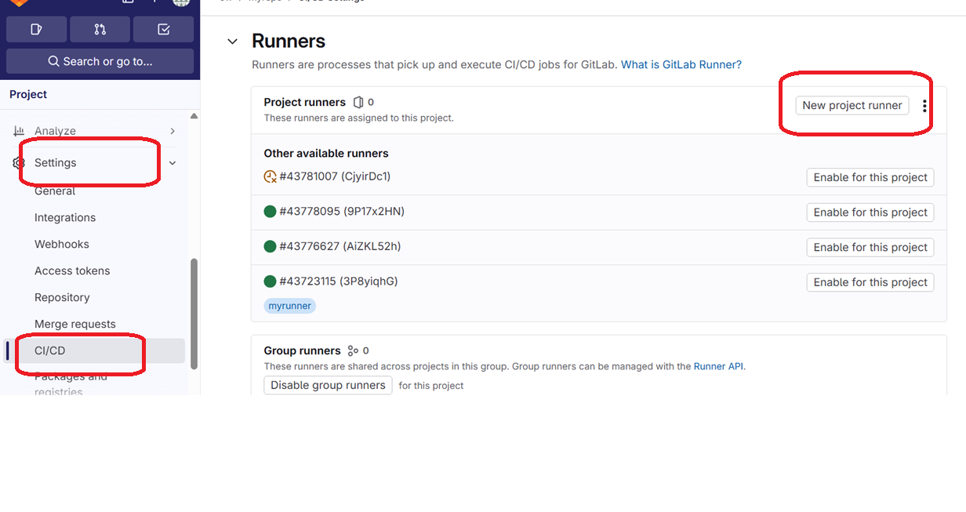

Provide details

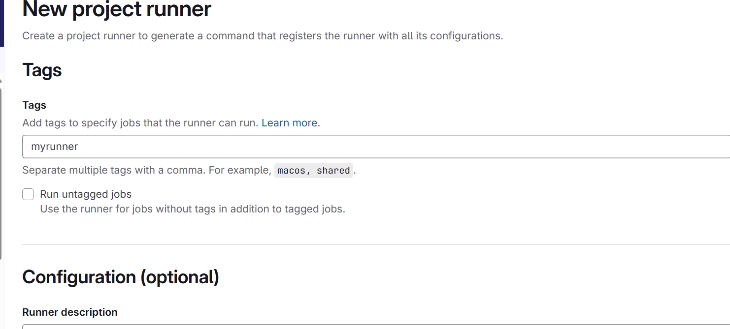

Create runner

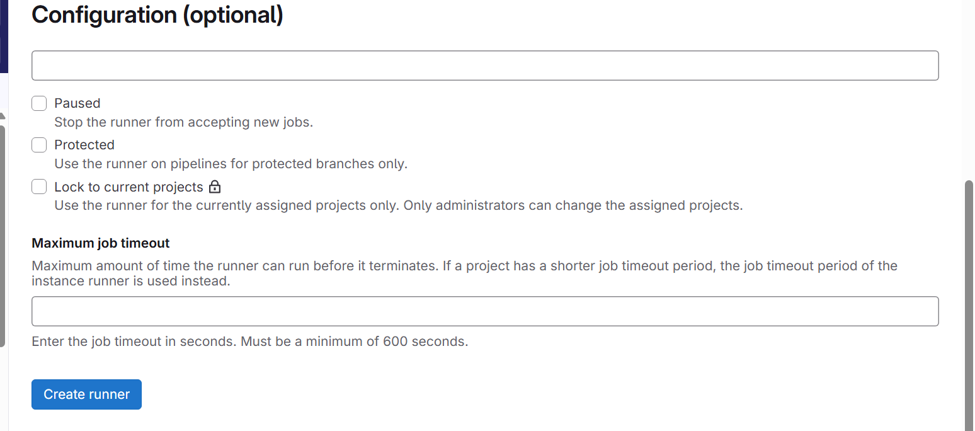

Register runner

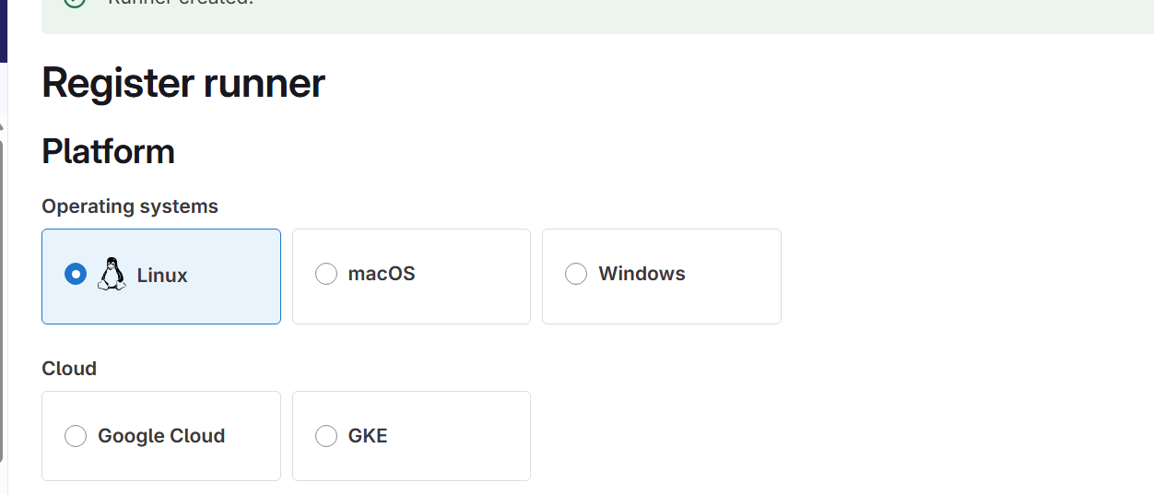

Install runner

# Download the binary for your system

sudo curl -L --output /usr/local/bin/gitlab-runner https://gitlab-runner-downloads.s3.amazonaws.com/latest/binaries/gitlab-runner-linux-amd64

# Give it permission to execute

sudo chmod +x /usr/local/bin/gitlab-runner

# Create a GitLab Runner user

sudo useradd --comment 'GitLab Runner' --create-home gitlab-runner --shell /bin/bash

# Install and run as a service

sudo gitlab-runner install --user=gitlab-runner --working-directory=/home/gitlab-runner

sudo gitlab-runner start

**Register GitLab Runner**

Get the **registration token** from:

* GitLab UI → Admin Area → Runners → Registration token  
  or

Project → Settings → CI/CD → Runners

Then run:

sudo gitlab-runner register

You’ll be prompted for:

Enter the GitLab instance URL: http://gitlab.example.com/

Enter the registration token: <TOKEN>

Enter a description for the runner: my-runner

Enter tags for the runner: docker,build

Enter an executor: shell, docker, docker+machine, kubernetes

For example, to use Docker executor:

executor: docker

default image: alpine:latest

Customize your CI file

job1:

tags:

- myrunner

script:

- echo "Hello from GitLab CI"

Check the output